Pursuant to the Mid-East Texas Groundwater District’s Management Plan:
Management Goal 6 – Addressing Drought Conditions
6.1 Objective – Each month, the district will download available drought information, for the counties in the district, from available websites on the internet.
6.2 Performance Standard – Quarterly, the District will assess the status of drought in the district and prepare a quarterly briefing for the Board of Directors. The downloaded maps reports, and information will be included with copies of the quarterly briefings and combined with results of groundwater monitoring data and permitted pumping data in the District Annual Report to the Board of Directors.
This report attempts to accomplish the goal of indicating drought conditions from two (2) sources. On page 2 is a map obtained from the U.S. Drought Monitor for the State of Texas. Also, on page 2 is a map indicating the Palmer Drought Severity Index for the United States. The area of interest is indicated by a bold black circle. An explanation of each of these maps is found on page 3.
Also included on page 3 is a map indicating the U.S. Seasonal Drought Outlook showing drought tendency during the valid period. This map was released on January 16, 2026 and is valid from January 16, 2026 to April 30,2026.
Located on page 4 are maps showing the current water levels for two (2) reservoirs that are within the district. The first chart is for Lake Limestone located in western Leon County. The other chart is for Richland-Chambers Reservoir located in northeastern Freestone County.
Based on this information and analysis by the district, the following assessments for drought are:
U.S. Drought Monitor – According to the U.S. Drought Monitor, Freestone & Leon County are showing Severe Drought while Madison County is in Moderate Drought.
Palmer Drought Severity Index (PDSI) – The District is in a “Moderate Drought” state.
U.S. Seasonal Drought Outlook – Drought remains but improves for most of the district in the predictive period of April 16, 2026 to July 31, 2026.
Lake Levels – Limestone is 84.1% full as of 4/23/2026; Richland-Chambers is 92.4% full as of 4/23/2026.

Prepared by David M. Bailey, General Manager - METGCD
_____________________________________________________________________________
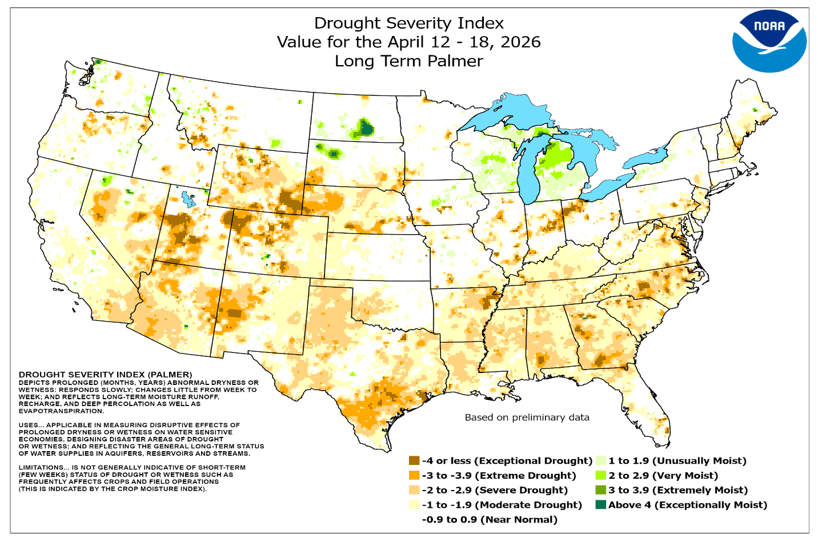

The U.S. Drought Monitor, established in 1999, is a weekly map of drought conditions that is produced jointly by the National Oceanic and Atmospheric Administration, the U.S. Department of Agriculture, and the National Drought Mitigation Center (NDMC) at the University of Nebraska-Lincoln. The U.S. Drought Monitor website is hosted and maintained by the NDMC. The map is based on measurements of climatic, hydrologic and soil conditions as well as reported impacts and observations from more than 350 contributors around the country. Eleven climatologists from the partner organizations take turns serving as the lead author each week. The authors examine all the data and use their best judgment to reconcile any differences in what different sources are saying.

The Palmer Drought Severity Index (PDSI) is a meteorological drought index based on recent precipitation and temperature and is used to assess the severity of dry or wet spells of weather. It is a soil moisture algorithm calibrated for relatively homogeneous regions. The PDSI is a long-term cumulative indicator for drought and wet conditions. PDSI values generally range from -6 to +6, with negative values denoting dry spells, and positive values denoting wet spells. Note: the methodology used to calculate the weekly PDSI is different from that used to calculate the monthly PDSI and the numbers are not comparable.
____________________________________________________________

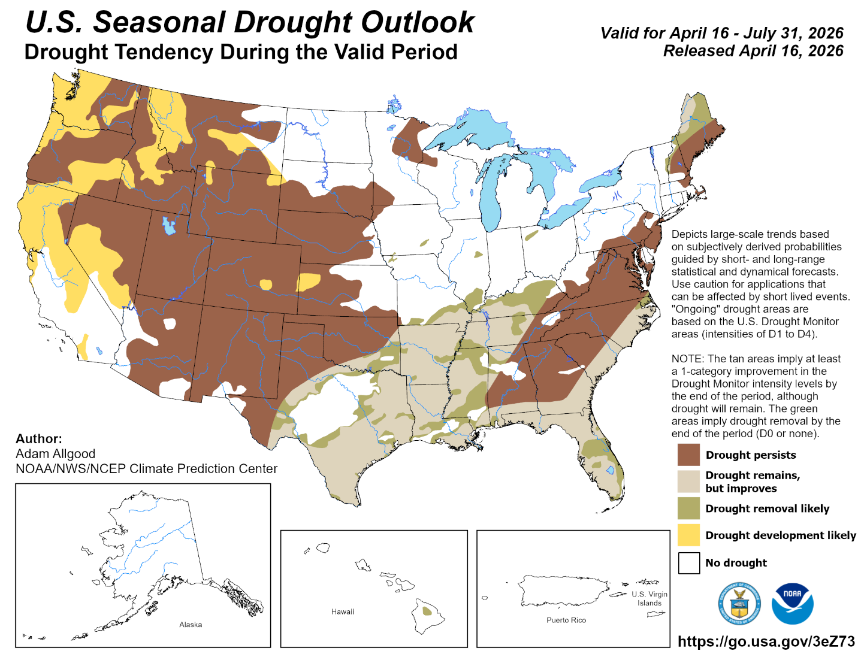

Lake Levels for Limestone and Richland-Chambers Reservoirs

Lake Limestone is 84.1% full as of 2026-4-23.

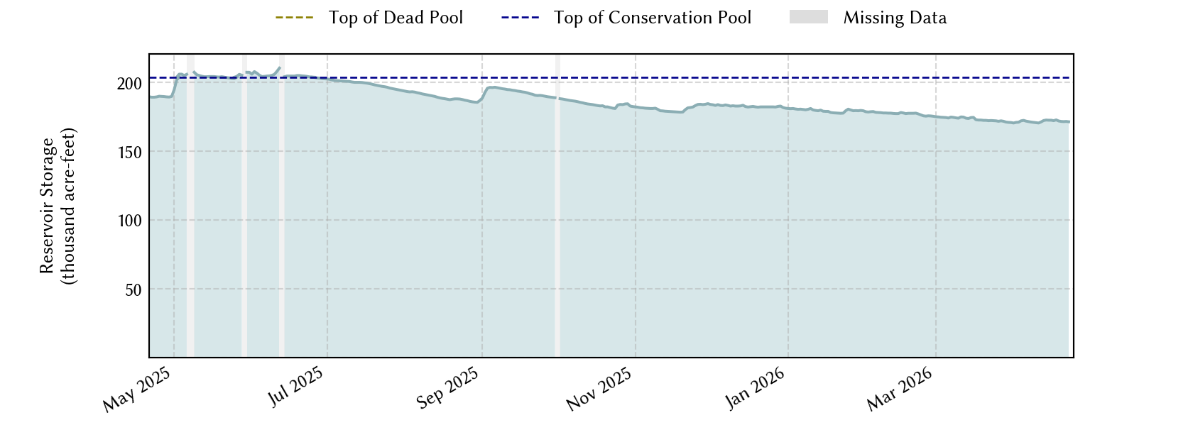

Impoundment Date – 1978-01-01 Lake Level as of 2026-4-23
Conservation Pool Elevation – 363 feet
Dead Pool Elevation – 322 feet 360.28 Feet
___________________________________________________________________

Richland-Chambers Reservoir is 92.4% full as of 2026-4-23.

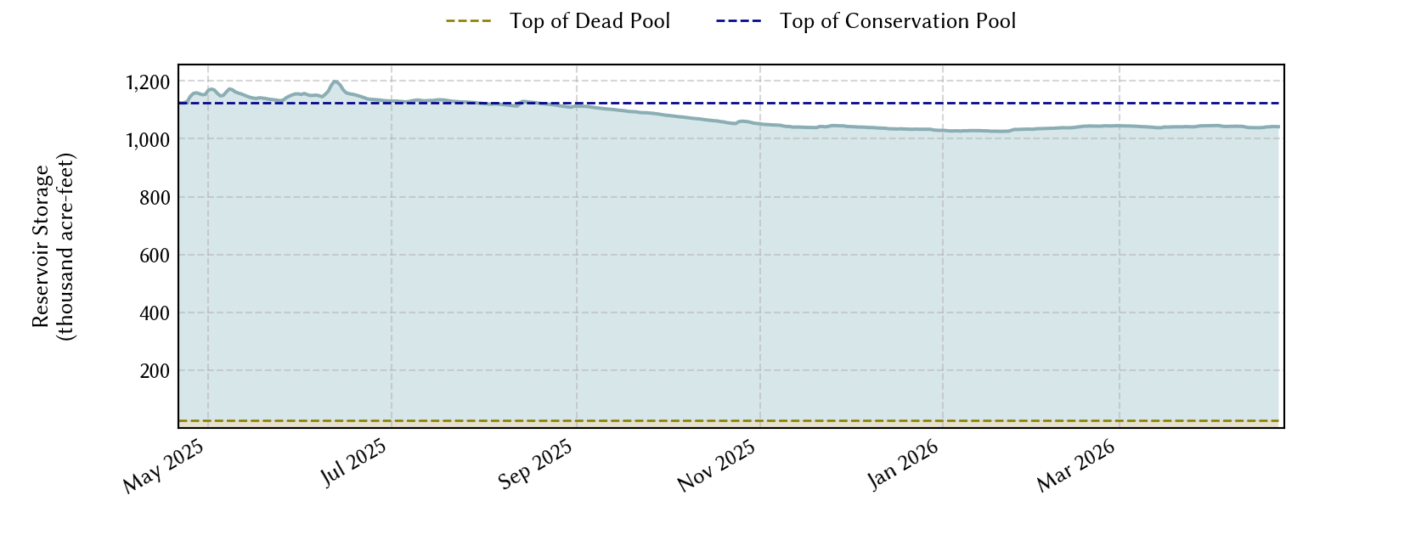

Impoundment Date – 1987-01-01 Lake Level as of 2026-4-23
Conservation Pool Elevation - 315 feet
Dead Pool Elevation – 266 feet 313.07 Feet

